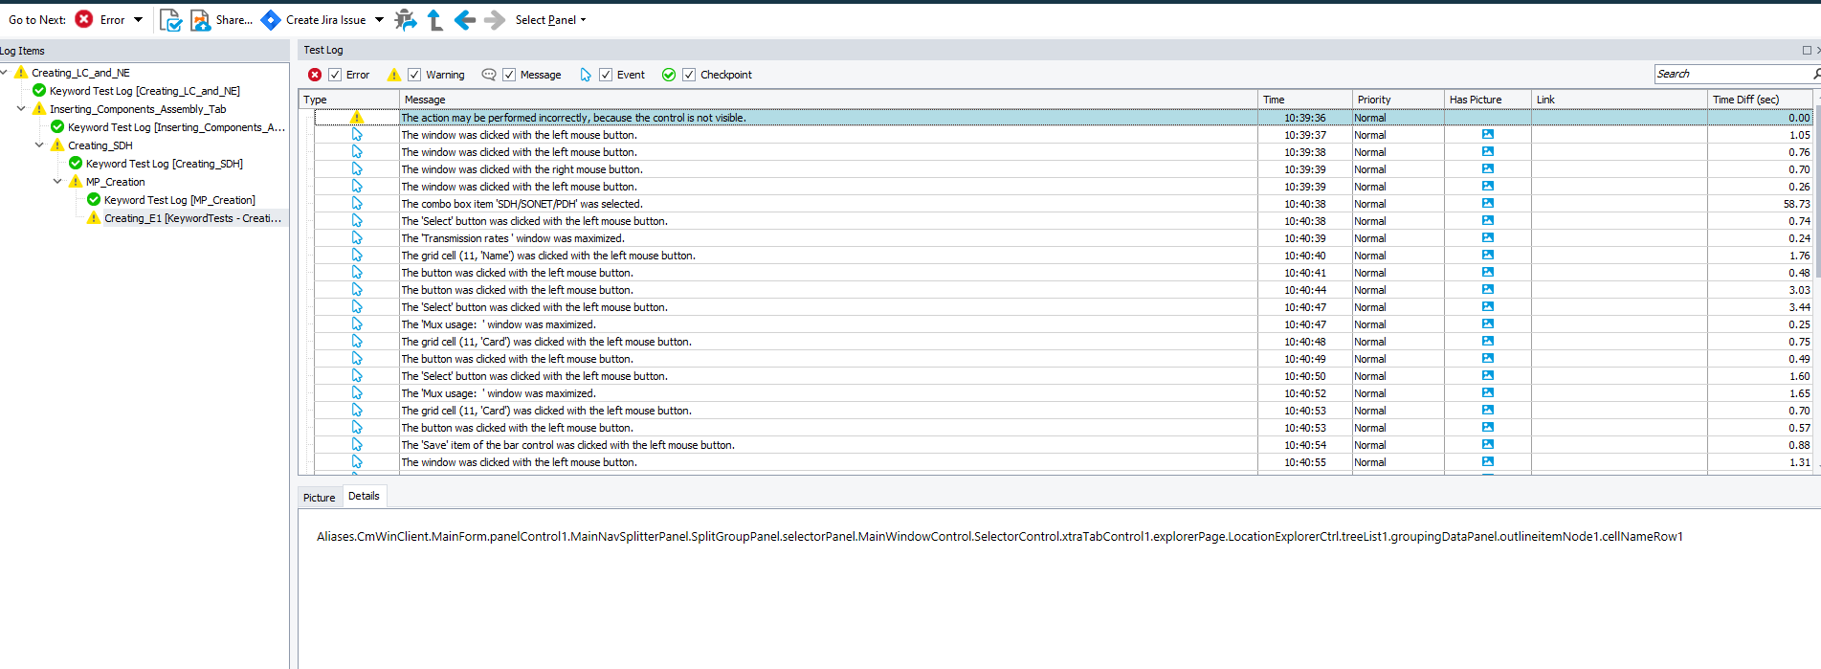

Aliases.CmWinClient.MainForm.panelControl1.MainNavSplitterPanel.SplitGroupPanel.selectorPanel.MainWindowControl.SelectorControl.xtraTabControl1.explorerPage.LocationExplorerCtrl.treeList1.groupingDataPanel.outlineitemNode1.cellNameRow1